

**‘Travel World’ Design Document**

by

Abhijeet Sawant

Submitted in Partial Fulfillment of the Requirements of DGM6501

To

Prof. Velda Shaby

September 2018

**Table of Content**

Introduction………………………………………………………………………... 3

Navigation…………………………………………………………………………. 4Site Map……………………………………………………………………............ 5Wire Frame……………………………………………………………………... 6 - 8

Font Used………………………………………………………………………….. 9

Color Scheme…………………………………………………………………….. 10

Conclusion……………………………………………………………………….. 11

1. **Introduction:**

In this website, I am providing detail information of famous locations of Boston and New York city. For example Museum of fine art, Statue of liberty, etc. The information includes history of the location, available ways of transportation, hours of operation, and trip cost. The audience I am planning to target with this website are the peoples who love to travel and are planning to visit places and cities mentioned above.

I have selected this topic because, I love to travel and visit different cities, places. So, before visiting any place I always tried to find different information about that place on the internet. This information really helps me to take a decision regrading whether to visit the place at this time or not, and if yes then what are the famous spot which I can visit with available transit system.

1. **Navigation:**



The Navigation bar is consist of 3 main elements and 2 sub navigation elements i.e. Home, Locations and Support and under location element Boston & New York sub elements. Each element is a link which redirect user to the appropriate page when it is clicked.

The navigation bar is available on all web pages. The main intent of it is to makes user task easier by providing smoother navigation between web pages.

To match the navigation bar with the websites overall color scheme I have used Corn Silk as its background color. Also, I have used Banana Mania color for the active link which will help user to understand their current position (currently open page). To increase the visibility of the nav bar element I have used brown color i.e. whenever user hover over the element its color will change from black to brown.

1. **Site Map:**

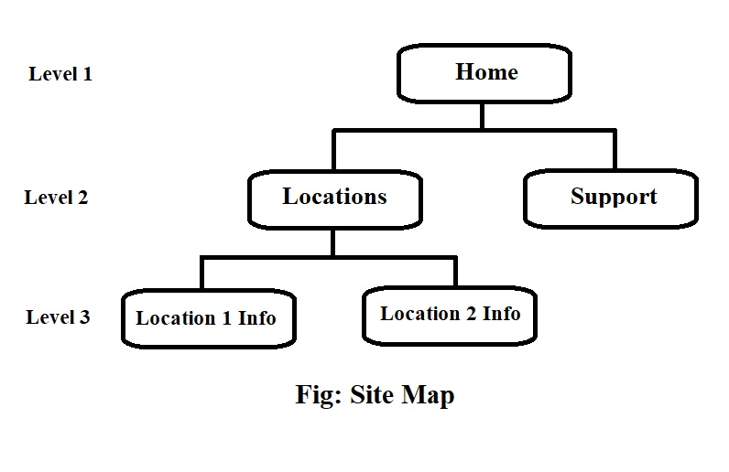

1. **Wire Frame:**

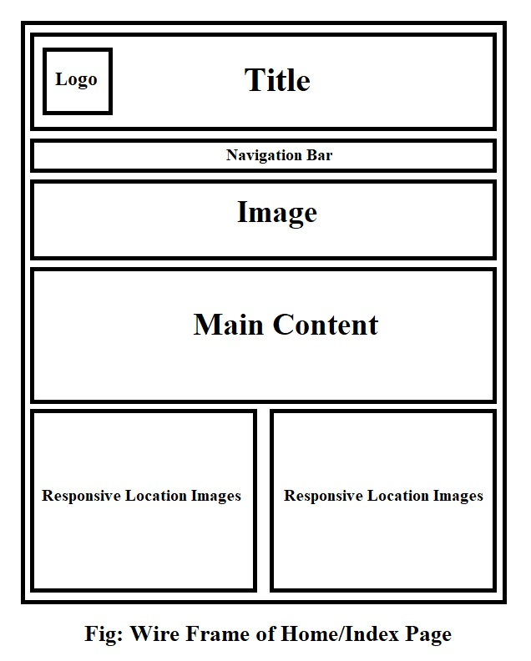

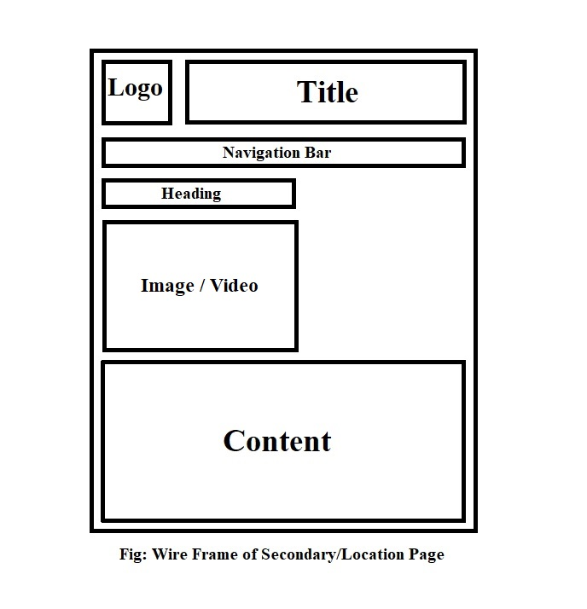

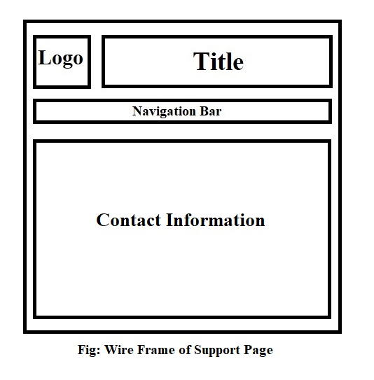

1. **Font Used:**

For my website I have used google fonts. Following list show the font family I have used:

1. **Lobster:** used for ‘Title’
2. **Teko:** used for ‘Navigation bar’
3. **Baloo Bhaijaan:** used for ‘Image description/title’
4. **Righteous:** used for ‘Article heading’
5. **Playfair Display:** used for ‘Content/Paragraph’

I have used this font based on its style and the location on page where they are going to be used. Also, I have checked whether they are suitable with each other or not. For example the font of article heading should be suitable with the font used for paragraph.

1. **Color Scheme/ Palate:**

Following are the colors I have used for my website:

1. **Header/Heading:** #A52A2A (Brown)
2. **Navigation bar:** #fffae6 (Corn Silk)
3. **Sub-Navigation bar:** #ffe6b3 (Moccasin)
4. **Active Tab:** #fff0b3(Banana Mania)
5. **Text:** #000000 (Black)
6. **Table Background:** #C0C0C0 (Silver)

I have used this color scheme because they are giving pleasant experience to the customers eye. These color shades are matching with each other which is improving the overall feel of the site and helping customer to understand and navigate easily from content and pages.

1. **Conclusion:**

This Project gave me a lot of technical knowledge of the web development. The part I enjoyed a lot is adding transition and animation effect in to my website. As they are really interesting. While on the other hand content alignment and adding ham burger menu into the website is really a hard task. It needs greater understanding of the content property in order to align them properly.

In my view I could do better work on my location web pages to look them better and more attractive. Also, I could align and add more content wisely.